Predictors of Outcome of Decompressive Craniectomy Following Traumatic Brain Injury
Omar Yousri Basuoni, Ahmed Mohamed Deabes, Ramy Abdelmenam Teama, Mahmoud Mohamed Wahdan , Ashraf El-dosouky El-tantawy
Neurosurgery , Dept., Faculty of Medicine, Benha Univ., Benha, Egypt
Abstract
Background: Traumatic brain injury (TBI) is a worldwide major and challenging public health problem responsible for 39% global mortality. TBI is considered one of the leading causes of death in pediatrics and adults less than 45 years. This study aimed to primarily evaluate the outcome of decompressive craniectomy (DC) in TBI and secondly to assess the factors that may predict the outcome of DC in those patients. Methods: This prospective cohort study was conducted on 30 patients with TBI with increased intracranial pressure not responding to medical treatment. All studied cases underwent neurological examination, radiological and laboratory investigations. Results: Regarding the factors associated with poor outcome, in the univariate analysis, it was found that older age, female gender, the lower the Glasgow coma scale (GCS) at admission, the longer duration between injury and operation, the more midline shift, presence of associated clinical features and bilaterality of DC . Those factors were significantly associated with poor outcome (death or severe disability), with p-values of 0.02, 0.03, 0.002, 0.02, 0.03, 0.01 and 0.04, respectively. In the multivariate analysis, only lower GCS, longer duration from injury and operation and bilaterality of DC were significant predictors associated with poor neurological outcome. Conclusion: We observed a high mortality rate of 46.7%. Factors such as old age, lower GCS at admission, longer time from injury to surgery, presence of bilateral unreactive pupils, associated injuries, and female gender were associated with poor outcomes. While midline shift improved postoperatively, complications such as residual subdural hematoma and wound infections were common.
Keywords: Decompressive Craniectomy, Traumatic Brain Injury.
Introduction
Traumatic brain injury (TBI) is a worldwide major and challenging public health problem responsible for 39% global mortality (1). TBI is considered one of the leading causes of death in pediatrics and adults less than 45 years of age (2). TBI can also be classified pathologically as focal injury which constitutes extra-axial (subdural and epidural) or intraparenchymal hematomas, and hemorrhagic contusions or diffuse injury involving widespread damage to axons, diffuse microvascular injury, hypoxic ischemic injury, and brain swelling (3).
In TBI, the primary insult which affects the brain parenchyma or cerebral blood vessels is a physical insult due to the direct traumatic event that is not preventable while secondary brain insult which usually happens due to intracranial hypertension, brain ischemia, or seizures can be prevented (4). The important point to save patients with severe TBI is prevention or decreasing secondary brain damages by medical and surgical therapies (5).
Medical treatment for brain edema and elevated ICP consists of analgesia, sedation, head elevation, cerebrospinal fluid drainage via a ventricular catheter, and optimization of ventilation to prevent cerebral vasodilation secondary to hypercarbia, administration of hyperosmolar solutions such as mannitol, moderate hypothermia, and barbiturate induced coma (6). In these patients that are refractory to medical therapy, decompressive craniectomy (DC) could be performed (7).
DC is surgical procedure that involves removal of part of the skull to accommodate brain swelling (8). ICP returns to normal level within 4 weeks after trauma and according to this finding DC which decreases the ICP will modify the pathogenesis and can decrease the mortality during the initial 4 weeks of trauma (9). Demographic, clinical, radiological factors and associated injuries may predict outcome of DC after traumatic brain injury (10).
The purpose of this study was to primarily evaluate the outcome of DC in TBI and secondly to assess the factors that may predict the outcome of DC in those patients.
Patients and methods
This prospective study was conducted on 30 patients with TBI with increased intracranial pressure not responding to medical treatment, who were admitted to Neurosurgery Department, Benha University Hospitals from Mars 2023 to Mars 2024.
An informed written consent was obtained from the patients. Every patient was examined and had a secret code number. The study was done after being approved by the Research Ethics Committee, Faculty of Medicine, Benha University.
Inclusion criteria included:
*early DC conducted within 12h for patients younger than 65years with Glasgow coma scale (GCS) <10 with CT brain findings of diffuse injury or had mass lesion to be evacuated.
*late DC which was done in case of increasing intracranial pressure which does not respond to brain dehydrating measures or deterioration of conscious level.
Exclusion criteria were patient with GCS= 3, non-traumatic patient with increase intracranial tension who may need DC, and patient who was generally unfit for surgery.
All studied cases were subjected to the following: Detailed history taking, including [history of trauma, associated multiple organs trauma and associated medical comorbidity]. Examination including: [General examination (vital signs, and primary survey; A, B, C, D, E according to ATLS protocols] and neurological examination (GCS, pupil size on both sides, and motor and sensory examination). Investigations including: Radiological [ initial CT brain on admission and after 24hours were done as it represents a gold standard of evaluating extent of brain edema, basal cisterns and hematoma (site, size, volume of hematoma) and also the degree of midline shift which is necessary for surgical decision, urgent CT brain follow up was done in case of deterioration of the patients GCS during their hospital observation which may be an indication to surgical intervention, and post operative CT brain follow up was done after surgery within 24 hours and was repeated at 6 months post-operative period]. Laboratory: [complete blood count, coagulation profile PT, PTT and INR, and liver and kidney function tests].
All patient data was registered regarding age, sex, relevant past medical history, type and time of trauma, GCS, pupil size, vital sign, neurological deficits, other associated injuries, CT brain findings, and duration of ICU stay, and hospital stay post operative.
Follow up was done for at least 6 months after DC to assess the survival rate and neurological outcome regarding Glasgow outcome score which categorizes the outcome of patients after TBI as follows: death, persistent vegetative state, sever disability, moderate disability, and good recovery. We analyzed the factors to prove their effect on outcome as age, gender, type and time of trauma, preoperative GCS and degree of midline shift.
Approval code: MS 19-6-2023
Sample size:
The following simple formula was used for calculating the minimal sample size; n== (z α/2 σ/E) 2 where: z α/2: The z critical value. E: The desired margin of error. σ: The population standard deviation. So the minimal calculated sample size was 20 participants . the number will be increased to 30 participants to allow for drop out cases.
Statistical analysis:
Statistical analysis was done by SPSS v26 (IBM Inc., Armonk ,NY, USA). Quantitative variables were presented as mean and standard deviation (SD) and compared between the two groups utilizing unpaired Student's t- test. Qualitative variables were presented as frequency and percentage (%) and were analysed utilizing the Chi-square test or Fisher's exact test when appropriate. P value < 0.05 was considered statistically significant.
:
Results
Table 1 shows the demographic data, mechanism and time of injury of included patient in our study .The GCS on admission was 3 in 13.3% of the studied cases, 26.7% and 23.3% of studied cases had score 4 and score 5 respectively, while 36.7% of them had score > 6. pupillary reaction assessed on examination , it was found reactive in 16 cases (53.3%) and bilaterally unreactive in 4 cases (13.3%). The associated injuries were present in 43.3% (13 out of 30 cases) mainly hemothorax in 3 cases (10%), fracture ribs in 2 cases (6.7%), hemothorax with fracture
ribs or fracture long bones in6 cases (20%) and mild abdominal collection in 1case(3.3%) . The four cases with hemothorax and fracture ribs died indicating more severe trauma. the side of DC was either right or left among 36.7% for each and only in 8 cases (26.7%) had bilateral DC. The range of midline shift was 0.5 up to 1.9 mm. the most prominent pathology found was ASDH among 73.4% of cases, while 10% had contusions and 5 cases (16.7%) had both ASDH with EDH or edema.
Table 2 shows improvement in level of midline shift, that decreased to be 0.51 ± 0.28 and ranged postoperatively from 0.2 to 1.1 mm, while mean of hospital stay was 16.2 days. Residual SDH alone was found in 5 cases (16.6%) and the incidence of wound infection alone was in 5 cases (16.6%) and only one case (3.3%) had both residual SDH and wound infection, two cases had postoperative pneumonia, the management of both cases was conservative responded to good antibiotics following culture and sensitivity. the mortality rate was 46.7. The overall mortality rate (Grade I) 46.7%. , while 33.4% were left with severe disability or persistent vegetative state (GOS II-III). and The functional recovery rate (Grades IV and V) was 10% for each.
Table 3 shows statistically significant decreased GCS and the longer duration from time of injury to time of operation in non-survival group.
Regarding the factors which may predict the outcome, in the univariate analysis, we found that older age, female gender, the lower the GCS at admission, the longer duration between injury and operation, the higher midline shift, presence of associated clinical features and bilaterality of DC side were significantly associated with poor outcome (death or severe disability), with p-values of 0.02, 0.03, 0.002, 0.02, 0.03, 0.01 and 0.04, respectively. In the multivariate analysis, only lower GCS, longer duration between injury and operation and bilaterality of DC were significant predictors associated with poor neurological outcome. Table 4
Case1:
A male patient 31-years-old presented to us 5 hours after RTA.GCS on admission was 6/15 ,pupillary reaction was unilateral. CT scan revealed right acute subdural hematoma with thickness 1 cm and midline shift 1.5 cm. The patient was operated upon by right Decompressive Craniectomy. 24 hours post-operatively the patient had the same GCS for one week then became with GCS 3/15 with dilated pupils and lost corneal reflexes. His 24 hours postoperative CT scan showed improved midline shift. The patient died after 10 days. Figure 1
Case2:
A female patient 49-year-old presented to us 3 hours after RTA.GCS on admission was 7/15, pupillary reaction was unilateral, the case had associated right hemothorax and a chest tube was inserted. CT scan revealed left acute subdural hematoma with thickness 1.4 cm and midline shift 1.3 cm. The patient was operated upon by left Decompressive Craniectomy. 24 hours postoperatively patient had the same GCS for 2 days then became with GCS 3/15 with dilated pupils and lost corneal reflexes. 24 hours postoperative CT scan showed improved midline shift and residual subdural hematoma. The patient died after 7 days. Figure 2
Discussion
Intracranial hypertension during the first 48 hours after TBI was found to be a predictor factor for mortality in patients with head injury (11), and recently, it was reported that ICP returns to normal level within 4 weeks from the trauma (12)
Our study population consisted of 16 males (53.3%) and 14 females (46.7%), with ages ranging from 22 to 57 years (mean 36.2 ± 10.6).
This gender distribution is similar to that reported by Khalili et al. (13), who found a male predominance (70.7%) in their study of 41 TBI patients undergoing DC. They reported a mean age of 34.8 years in their cohort.
We observed a trend of increasing mortality associated with age, which is consistent with previous literature. For instance, De Bonis et al. (14) reported that age >65 years was a significant predictor of poor outcome in TBI patients undergoing DC.
In our study, the time from injury to surgery ranged from 2 to >6 hours, with the majority of cases (53.3%) operated on between 4-6 hours post-injury.
This timing is crucial, as several studies have emphasized the importance of early DC in improving outcomes. For example, Zhao et al. (15) found that ultra-early DC (within 4 hours) was associated with better outcomes compared to early DC (4-24 hours).
In our study, the mean GCS on admission was 3.93 ± 1.84, with 36.7% of patients having a score ≥6. This relatively low GCS score is consistent with the severe nature of TBI requiring DC.
Our findings align with those of Khalili et al. (13), who reported a mean GCS of 5.7 ± 1.8 in their study.
In our study, regarding pupillary reactions, 53.3% of our patients had reactive pupils, while 33.3% had unilateral unreactive pupils, and 13.3% had bilateral unreactive pupils.
Abouhashem et al. (16) reported that, the pupil examination was stratified into normal, constricted, isochoric, and dilated but reactive while patients with dilated non-reactive pupils were excluded and only isochoric pupils is the only type of pupils that showed significant difference between survivors and non-survival even after multiple regression as it decreases the odds of mortality.
In the univariate analysis, the presence of associated clinical features was significantly associated with poor outcome (p = 0.01). However, in the multivariate analysis, associated injuries did not emerge as an independent predictor of poor outcome.
Abouhashem et al. (16) reported that, presence of extra cranial injury increases the risk of early mortality, and lung injury and abdominal injury with internal hemorrhage were strong predictors for early mortality after decompressive craniectomy while spine and orthopedic injuries did not modify the odds of early mortality, and this can be explained by the associated hypotension and/or hypoxia in cases with abdominal trauma and lung injury respectively.
In our study, the most common pathological finding was acute subdural hematoma (ASDH) in 73.4% of cases, followed by contusions (26.6%).
This is consistent with other studies, such as Grindlinger et al. (17), who reported ASDH as the most common indication for DC in their series.
Our study showed a significant improvement in midline shift postoperatively, decreasing from a mean of 0.97 ± 0.44 mm to 0.51 ± 0.28 mm.
This reduction in midline shift is a key goal of DC and has been associated with improved outcomes in previous studies (18).
In our study, complications were observed in 43.3% of patients, with residual subdural hematoma (16.6%) and wound infection (16.6%) being the most common. These complication rates are within the range reported in the literature, although direct comparisons are challenging due to variations in definitions and follow-up periods across studies.
Our study reported a mortality rate of 46.7%, which is higher than some previous reports. For instance, Abouhashem et al. (16) reported a mortality rate of 30.77% in their series. This difference might be attributed to variations in patient characteristics, timing of surgery, or postoperative management protocols.
Khalili et al. (13) reported that, after 1-year, the mortality rate was 58 (40.8%) and 8 (5.6%) patients were persistent vegetative state.
Using the Glasgow Outcome Score (GOS), we found that 20% of patients achieved good functional recovery (GOS IV-V), while 33.4% were left with severe disability or persistent vegetative state (GOS II-III).
Those outcomes are somewhat less favorable than those reported by some other studies, such as Grindlinger et al. (17), who found good outcomes (GOS IV-V) in 41% of their patients.
In Our study, regarding the factors associated with poor outcome, in the univariate analysis, it was found that female gender was significantly associated with poor outcome (death or severe disability).
Abouhashem et al. (16) reported that, 92 males and 12 females had severe traumatic brain injury with significant difference between groups as the early mortality was reported in 66.67% of the female patients while in male patients, it was only 26.1%,
But in apparent disagreement was found in other studies which showed no differences in either acute complications or outcome after TBI between males and females (19, 20).
Our multivariate analysis identified three significant predictors of poor outcome: lower GCS at admission, longer time from injury to surgery, and bilateral DC. These findings are largely consistent with previous literature.
These results are in agreement with Kodliwadmath et al. (21) who concluded that GCS can stratify the risk and prognosis in patients with traumatic brain injury but with caution in patients with polytrauma as other injuries can modify the morbidity and mortality.
Additionally, a higher GCS score, young age, and short interval between TBI and surgery can have a positive impact on patient outcomes (22).
Conclusion
In our study, we observed a high mortality rate of 46.7%. Factors such as old age, lower GCS at admission, longer time from injury to surgery, presence of bilateral unreactive pupils, associated injuries, and female gender were associated with poor outcomes. complications such as residual subdural hematoma and wound infections were the most common in our study. The study demonstrated the complexity of TBI management and the need for further research to optimize treatment strategies and improve patient outcomes.
Sources of funding
This research did not receive any specific grant from funding agencies in the public, commercial, and not-for-profit sectors.
Author contribution
Authors contributed equally to the study.
Conflicts of interest
No conflicts of interest
References
1. Brazinova A, Rehorcikova V, Taylor MS, Buckova V, Majdan M, Psota M, et al. Epidemiology of traumatic brain injury in Europe: a living systematic review. J neurotrauma. 2021;38:1411-40.
2. Bandyopadhyay S, Kawka M, Marks K, Richards GC, Taylor EH, Sravanam S, et al. Traumatic brain injury–related pediatric mortality and morbidity in low-and middle-income countries: a systematic review. World Neurosurg. 2021;153:109-30.
3. Clement MO. Imaging of brain trauma. Radiologic Clinics. 2019;57:733-44.
4. Monson KL, Converse MI, Manley GT. Cerebral blood vessel damage in traumatic brain injury. Clinical biomechanics. 2019;64:98-113.
5. Marehbian J, Muehlschlegel S, Edlow BL, Hinson HE, Hwang DY. Medical management of the severe traumatic brain injury patient. Neurocritical care. 2017;27:430-46.
6. Schizodimos T, Soulountsi V, Iasonidou C, Kapravelos N. An overview of management of intracranial hypertension in the intensive care unit. J Anesth. 2020;34:741-57.
7. Gopalakrishnan M, Shanbhag NC, Shukla DP, Konar SK, Bhat DI, Devi BI. Complications of decompressive craniectomy. Front Neurol. 2018;9:97-100.
8. Mraček J, Mork J, Dostal J, Tupy R, Mrackova J, Priban V. Complications following decompressive craniectomy. J Neurol Surg A Cent Eur Neurosurg. 2021;82:437-45.
9. Hutchinson PJ, Kolias AG, Tajsic T, Adeleye A, Aklilu AT, Apriawan T, et al. Consensus statement from the International Consensus Meeting on the Role of Decompressive Craniectomy in the Management of Traumatic Brain Injury: consensus statement. Acta neurochirurgica. 2019;161:1261-74.
10. Adatia K, Newcombe VF, Menon DK. Contusion progression following traumatic brain injury: a review of clinical and radiological predictors, and influence on outcome. Neurocritical care. 2021;34:312-24.
11. Badri S, Chen J, Barber J, Temkin NR, Dikmen SS, Chesnut RM, et al. Mortality and long-term functional outcome associated with intracranial pressure after traumatic brain injury. Intensive Care Med. 2012;38:18-29.
12. Lilja-Cyron A, Andresen M, Kelsen J, Andreasen TH, Fugleholm K, Juhler M. Long-Term Effect of Decompressive Craniectomy on Intracranial Pressure and Possible Implications for Intracranial Fluid Movements. Neurosurgery. 2020;86:231-40.
13. Khalili H, Niakan A, Ghaffarpasand F, Kiani A, Behjat R. Outcome Determinants of Decompressive Craniectomy in Patients with Traumatic Brain Injury; A Single Center Experience from Southern Iran. Bull Emerg Trauma. 2017;5:190-6.
14. De Bonis P, Pompucci A, Mangiola A, Rigante L, Anile C. Post-traumatic hydrocephalus after decompressive craniectomy: an underestimated risk factor. J Neurotrauma. 2010;27:1965-70.
15. Zhao HX, Liao Y, Xu D, Wang QP, Gan Q, You C, et al. Prospective randomized evaluation of therapeutic decompressive craniectomy in severe traumatic brain injury with mass lesions (PRECIS): study protocol for a controlled trial. BMC Neurol. 2016;16:1-10.
16. Abouhashem S, Albakry A, El-Atawy S, Fawzy F, Elgammal S, Khattab O. Prediction of early mortality after primary decompressive craniectomy in patients with severe traumatic brain injury. Egypt J Neurosurg. 2021;36:1-8.
17. Grindlinger GA, Skavdahl DH, Ecker RD, Sanborn MR. Decompressive craniectomy for severe traumatic brain injury: clinical study, literature review and meta-analysis. Springerplus. 2016;5:16-25.
18. Jeon SB, Kwon SU, Park JC, Lee DH, Yun SC, Kim YJ, et al. Reduction of Midline Shift Following Decompressive Hemicraniectomy for Malignant Middle Cerebral Artery Infarction. J Stroke. 2016;18:328-36.
19. Mushkudiani NA, Engel DC, Steyerberg EW, Butcher I, Lu J, Marmarou A, et al. Prognostic value of demographic characteristics in traumatic brain injury: results from the IMPACT study. J Neurotrauma. 2007;24:259-69.
20. Renner C, Hummelsheim H, Kopczak A, Steube D, Schneider HJ, Schneider M, et al. The influence of gender on the injury severity, course and outcome of traumatic brain injury. Brain INJ. 2012;26:60-71.
21. Kodliwadmath HB, Koppad SN, Desai M, Badiger SP. Correlation of Glasgow outcome score to Glasgow coma score assessed at admission. Int Surg J. 2016;3:1959-63.
22. Barthélemy EJ, Melis M, Gordon E, Ullman JS, Germano IM. Decompressive Craniectomy for Severe Traumatic Brain Injury: A Systematic Review. World Neurosurg. 2016;88:411-20.

Table 1: Demographic data, mechanism of injury, time of injury, The GCS on admission, pupillary reactions , associated clinical findings and pathological findings of the studied group
Variables |  | Studied group (N=30)  N (%)
Age  (Years) | Mean ± SD  Range | 36.2 ± 10.6  22-57
Gender | Male  Female | 16 (53.3%)  14 (46.7%)
Past medical history | No  HTN  DM  CHD | 16 (53.3%)  6 (20%)  10 (33.3%)  4 (13.3%)
Mechanism of head injury | Road traffic accident | 16 (53.3%)
Mechanism of head injury | Falling from height | 11 (36.7%)
Mechanism of head injury | Blunt trauma | 3 (10%)
Time from injury to operation (hrs.) | Mean ± SD | 4.22 ± 3.55
Time from injury to operation (hrs.) | 2-4 hrs. | 7 (23.3%)
Time from injury to operation (hrs.) | 4-6 hrs. | 16 (53.3%)
Time from injury to operation (hrs.) | >6 hrs. | 7 (23.3%)
GCS on admission | Mean ± SD | 3.93 ± 1.84
GCS on admission | 3 | 4 (13.3%)
GCS on admission | 4 | 8 (26.7%)
GCS on admission | 5 | 7 (23.3%)
GCS on admission | ≥6 | 11 (36.7%)
Pupillary reactions | Reactive | 16 (53.3%)
Pupillary reactions | Unilateral unreactive | 10 (33.3%)
Pupillary reactions | Bilateral unreactive | 4 (13.3%)
Associated clinical injuries | Present | 13 (43.3%)
Associated clinical injuries | Fracture ribs | 2 (6.7%)
Associated clinical injuries | Hemothorax | 3 (10%)
Associated clinical injuries | Fracture long bones | 1 (3.3%)
Associated clinical injuries | Abdominal collections | 1 (3.3%)
Associated clinical injuries | Combined injuries | 6 (20%)
Pathological findings
Side of DC | RT | 11 (36.7%)
Side of DC | LT | 11 (36.7%)
Side of DC | Bilateral | 8 (26.6%)
Midline shift  (cm) | Mean ± SD  Range | 0.97 ± 0.44  0.5 - 1.9
Associated pathology | ASDH | 22 (73.4%)
Associated pathology | Contusions | 3 (10%)
Associated pathology | Multiple pathologies including ASDH | 5 (16.6%)

Table 2: Postoperative assessment, complications, and Glasgow outcome score
Variables |  | Studied group  N=30
24h Post operative Radiological improvement(cm) | Mean ± SD  Range | 0.51 ± 0.28  0.2 – 1.1
Length of hospital stay (days) | Mean ± SD  Range | 16.2 ± 2.17  12 – 20
Complications | Present  Not | 13 (43.3%)  17 (56.7%)
Types | Residual SDH | 5 (16.6%)
Types | Wound infection | 5 (16.6%)
Types | Both | 1 (3.3%)
Types | Postoperative pneumonia | 2 (6.7%)
Mortality |  | 14 (46.7%)
Glasgow outcome score | I | 14 (46.7%)
Glasgow outcome score | II | 8 (26.7%)
Glasgow outcome score | III | 2 (6.7%)
Glasgow outcome score | IV | 3 (10%)
Glasgow outcome score | V | 3 (10%)

Table 3: Relation between survival rate and GCS on admission and the time duration between injury and operation
 | Survival | N | Mean ± SD | t-test | P
The time duration between injury and operation | No | 14 | 5.71 ± 1.22  (hours) | 5.17 | <0.001  HS
The time duration between injury and operation | Yes | 16 | 3.51 ± 1.11  (hours) | 5.17 | <0.001  HS
GCS | No | 14 | 2.65 ± 0.86 | 7.41 | <0.001  HS
GCS | Yes | 16 | 5.38 ± 1.12 | 7.41 | <0.001  HS
HS: highly significant.

Table 4: Predictors of bad outcome (Death or severe disability) among studied cases
 |  | Poor outcome  N=22 | Good outcome  N=8 | Univariate analysis P | Multivariate analysis
Age | Mean ± SD | 39.1 ± 11.6 | 31.3 ± 6.29 | 0.02 S | 0.234 NS
Gender | Male | 10 (62.5%) | 6 (37.5%) | 0.03 S | 0.234 NS
Gender | Female | 12 (85.7%) | 2 (14.3%) | 0.03 S | 0.234 NS
GCS | Mean ±SD | 3.16 ± 1.46 | 5 ± 1.41 | 0.002 S | 0.03 S
Time from injury | Mean ±SD | 5.65 ± 2.42 | 3.11 ± 1.12 | 0.02 S | 0.02 S
Mechanism of injury | RTA | 10 (71.4%) | 4 (28.6%) | 0.827 NS | 0.435 NS
Mechanism of injury | Others | 12 (75%) | 4 (25%) | 0.827 NS | 0.435 NS
Associated CL features | Present | 12 (92.3%) | 1 (7.7%) | 0.01 S | 0.104 NS
Associated CL features | Not | 10 (58.8%) | 7 (41.2%) | 0.01 S | 0.104 NS
Midline shift | Mean ± SD | 1.2 ± 0.45 | 0.86 ± 0.38 | 0.03 S | 0.112 NS
Pathology | ASDH | 15 (68.2%) | 7 (31.8%) | 0.112 | 0.232 NS
Pathology | Contusions | 7 (87.5%) | 1 (12.5%) | 0.112 | 0.232 NS
DC side | Bilateral | 8 (100%) | 0 | 0.04 S | 0.02 S
DC side | Unilateral | 14 (63.6%) | 8 (36.4%) | 0.04 S | 0.02 S
S: P-value<0.05 is significant, NS: P-value>0.05 is not significant

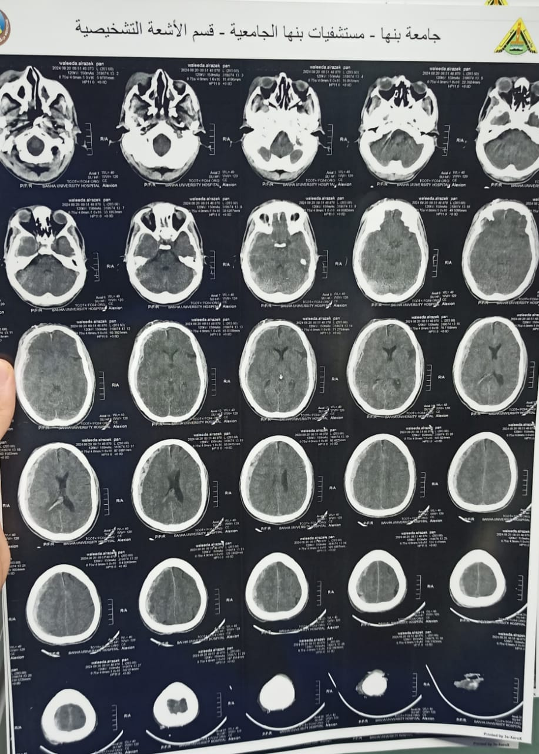
A | 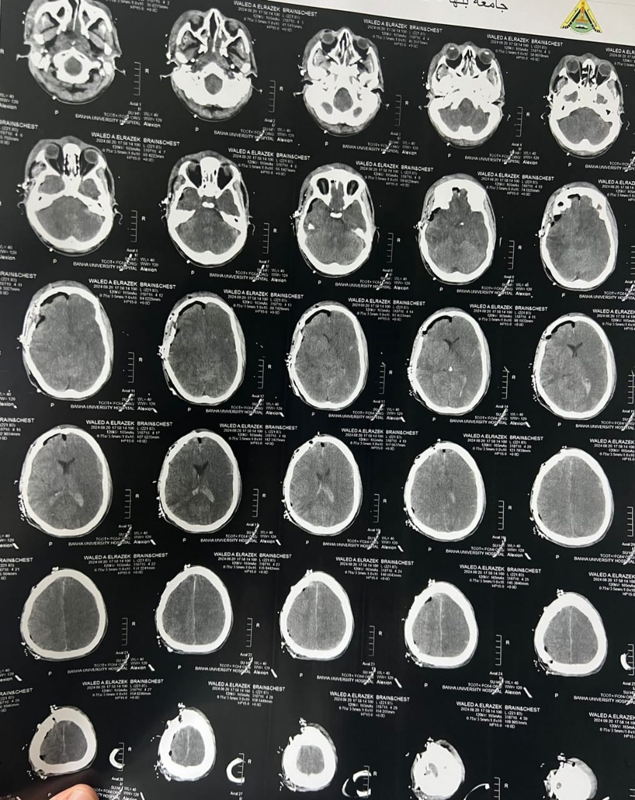  B
Figure 1: A: preoperative CT brain of case no.1: revealed right acute subdural hematoma with thickness 1 cm and midline shift 1.5 cm, B: 24 hours postoperative CT : revealed improved midline shift.

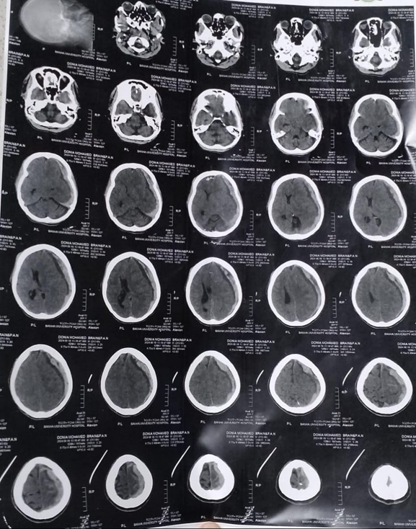  A | 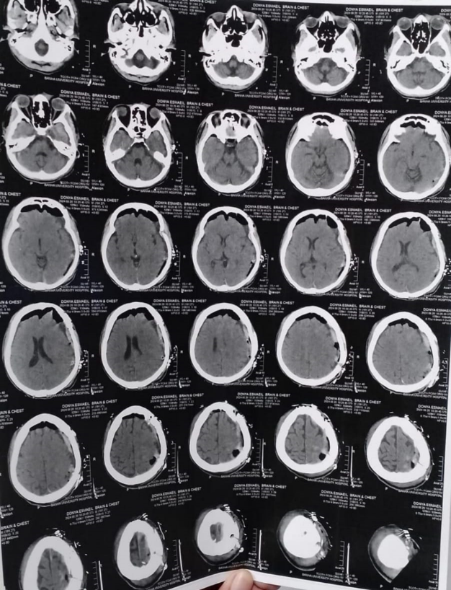  B
Figure 2: A: preoperative CT brain of case no.2: revealed left acute subdural hematoma with thickness 1.4 cm and midline shift 1.3 cm, B: 24 hours postoperative CT : revealed improved midline shift

